***ACKNOWLEDGEMENT***

*I NAMAN CHAURASIA THANK MY MULTIMEDIA AND WEB TECHNOLOGY TEACHER MISS MEENA DOGRA WHO HAS GIVEN ME HER CONSTANT SUPPORT AND IMAGINATIVE IDEAS TO MAKE MY PROJECT ON TRAVEL AND TOURISM A SUCCESS.I ALSO THANK MY PARENTS AND FRIENDS, WITHOUT WHOSE HELP THIS PROJECT WOULD NOT HAVE BEEN SUCCESSFUL.*

*THANKYOU*

*About the project*

The project is a website named “DUNIYA DEKHO.COM” based on travel and tourism. It gives information about different tourist places in India and in international places. The user can decide his place of vacation with the help of our website. It is divided into two sections, domestic and international. The pages are created with the use languages such as CSS, VBSCRIPT, HTML and ASP. Overall this project is a good experience to go through.

*ENJOY YOUR JOURNEY* ! ! ! !

*INDEX*

* *main.asp*
* *international.html*
* *Gallery.html*
* *Tips.asp*
* *page2.html*
* *Northdelhi.html*
* *Northjammu.html*
* *Southkerela.html*
* *Southgoa.html*
* *Eastbanglore.html*
* *Eastassam.html*
* *westindia.html*
* *France.html*
* *London.html*
* *Canada.html*
* *Japan.html*

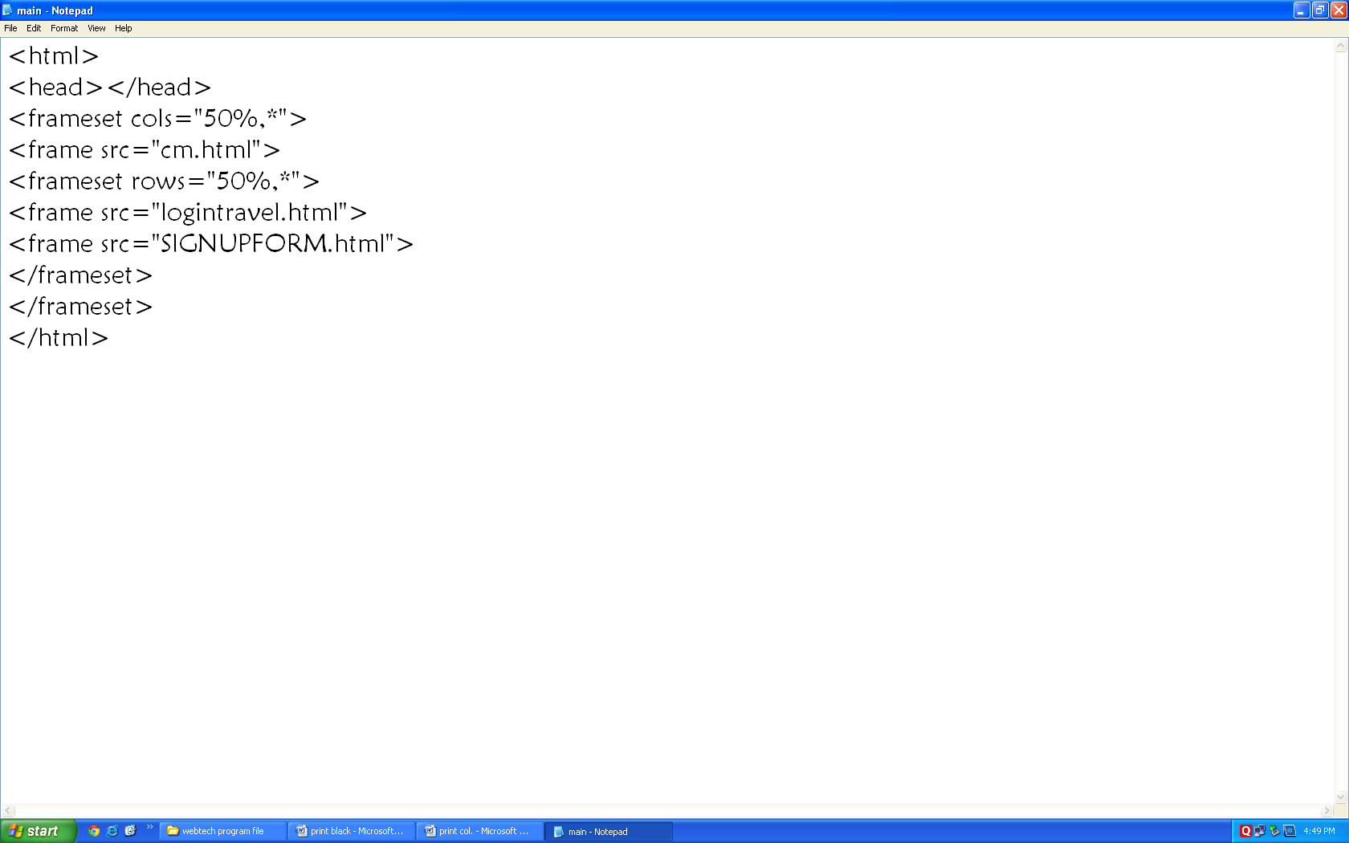

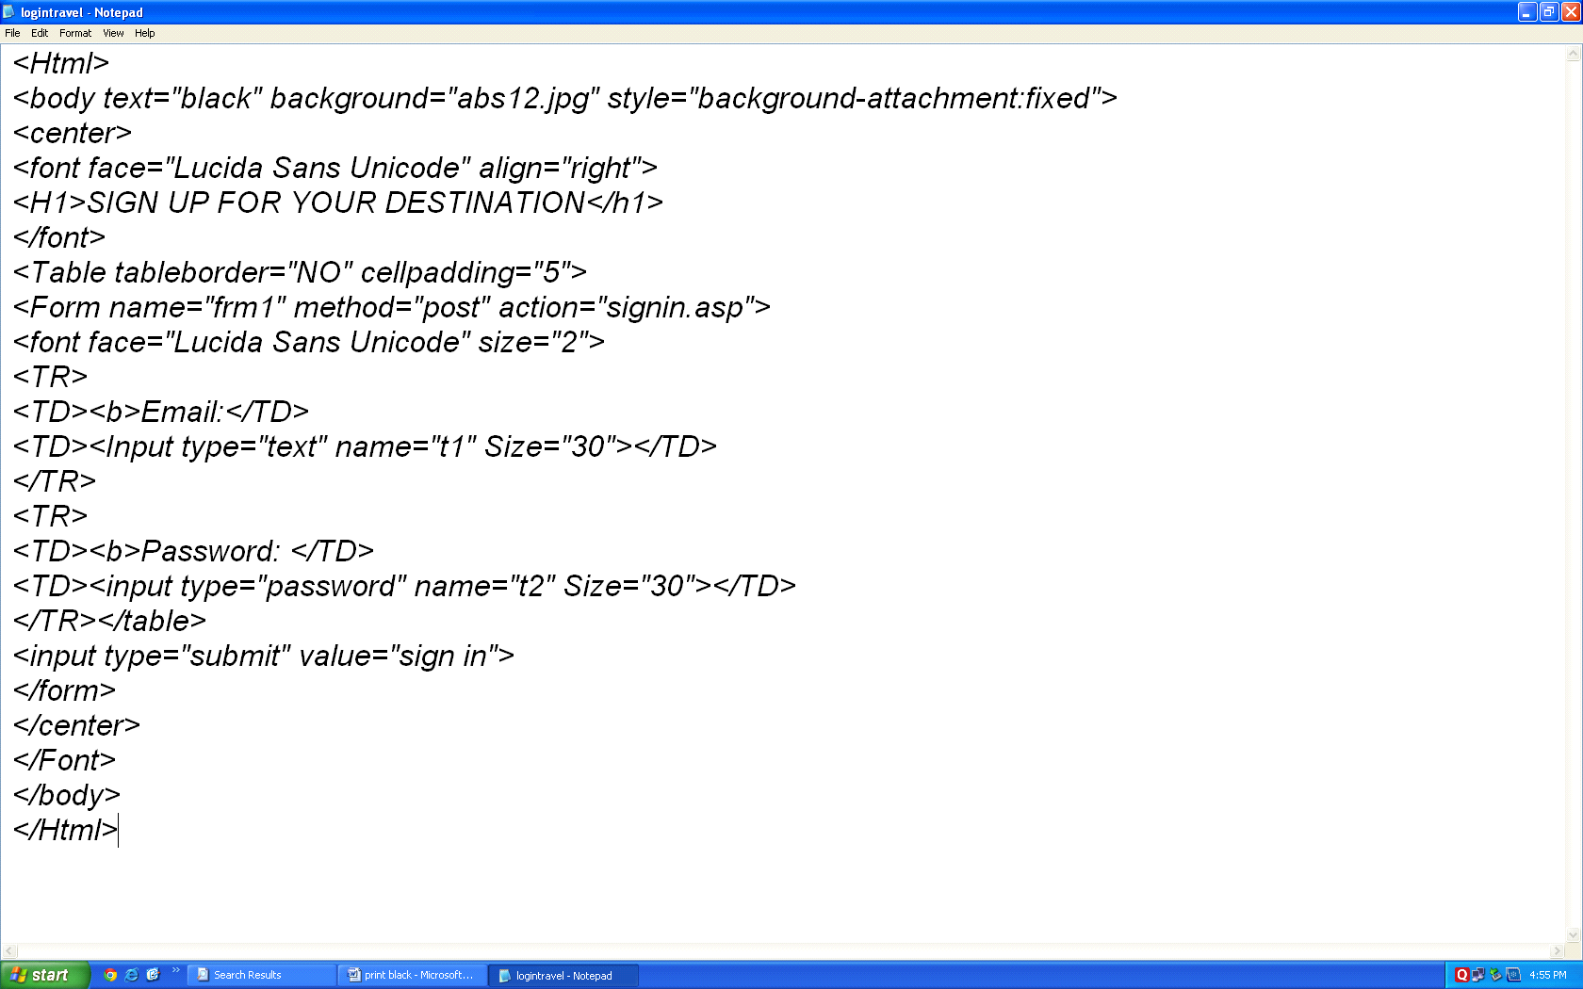

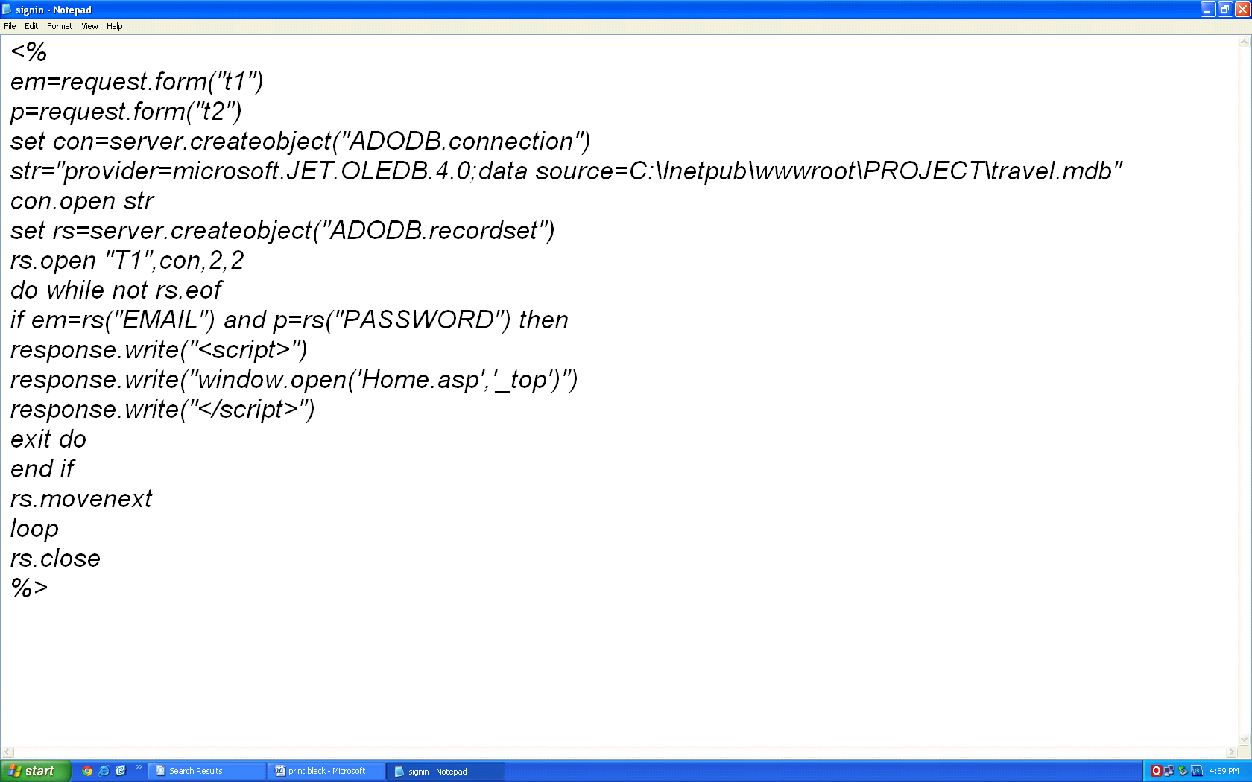

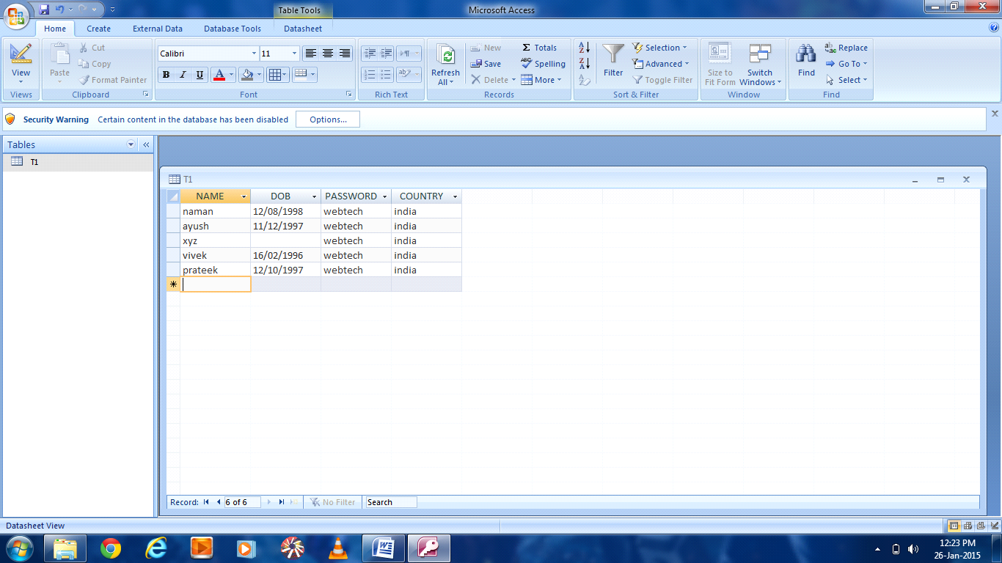

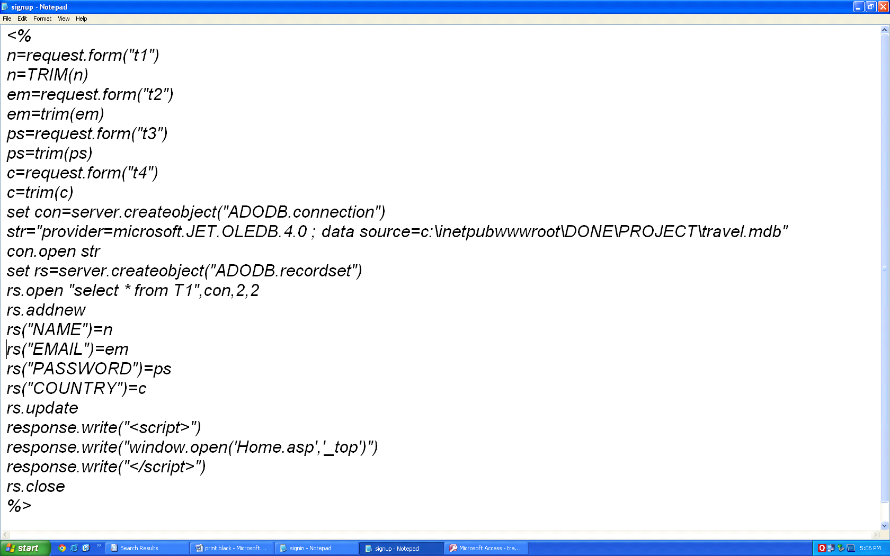

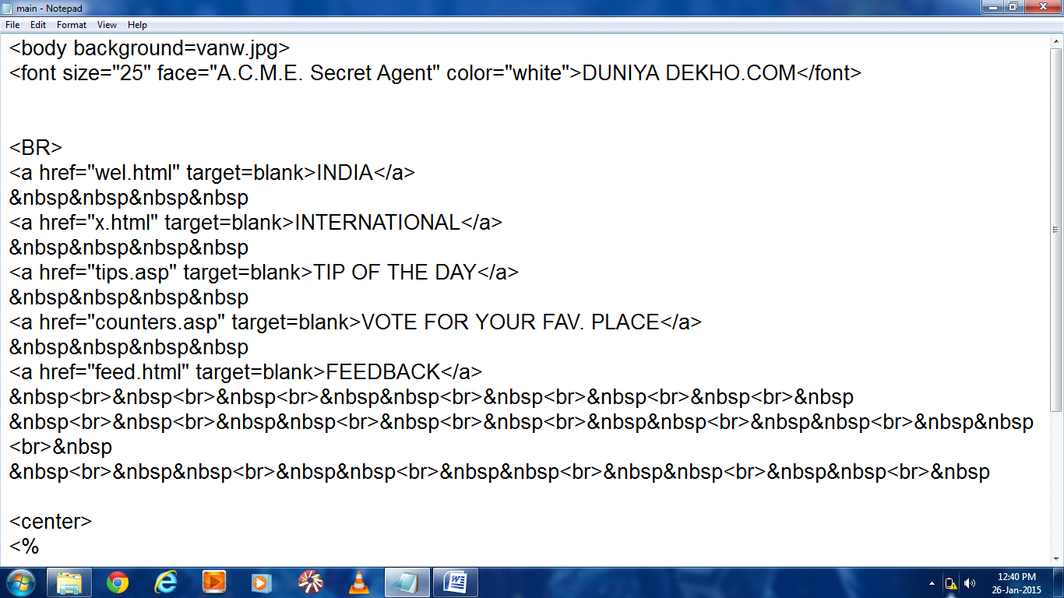

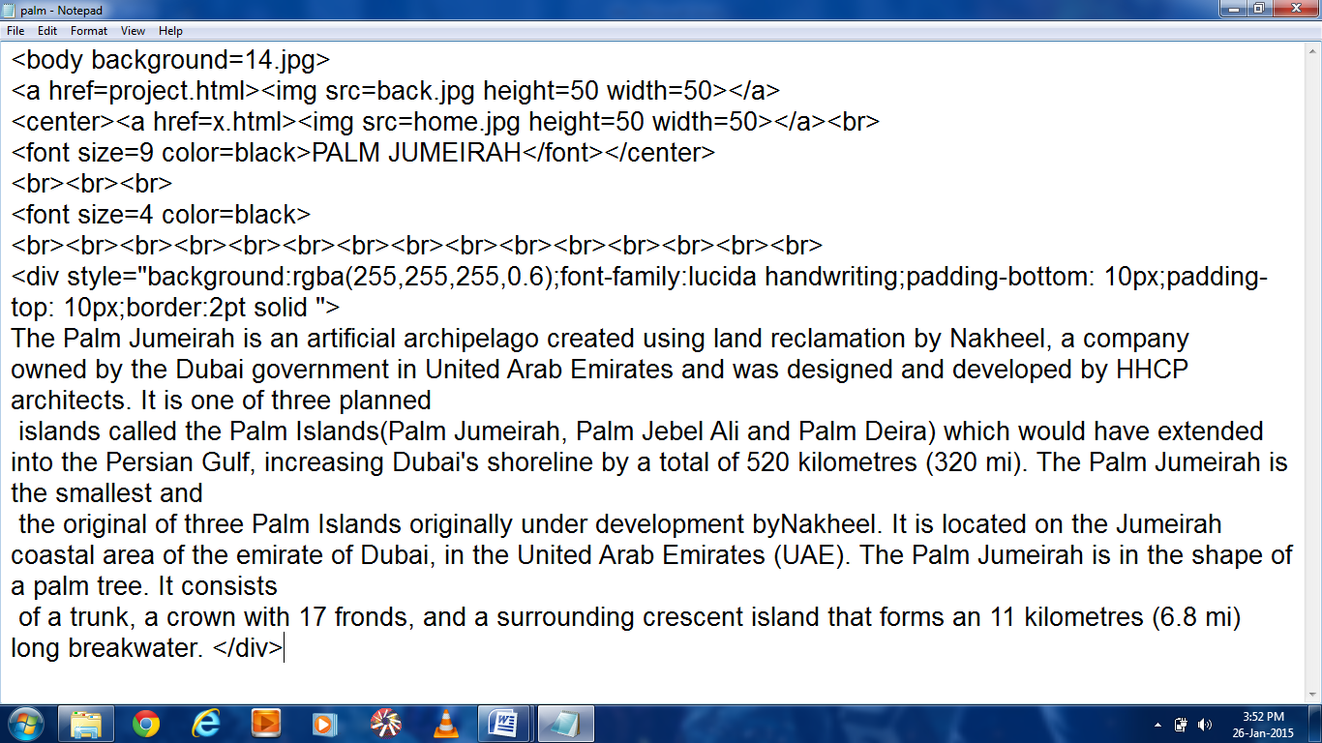

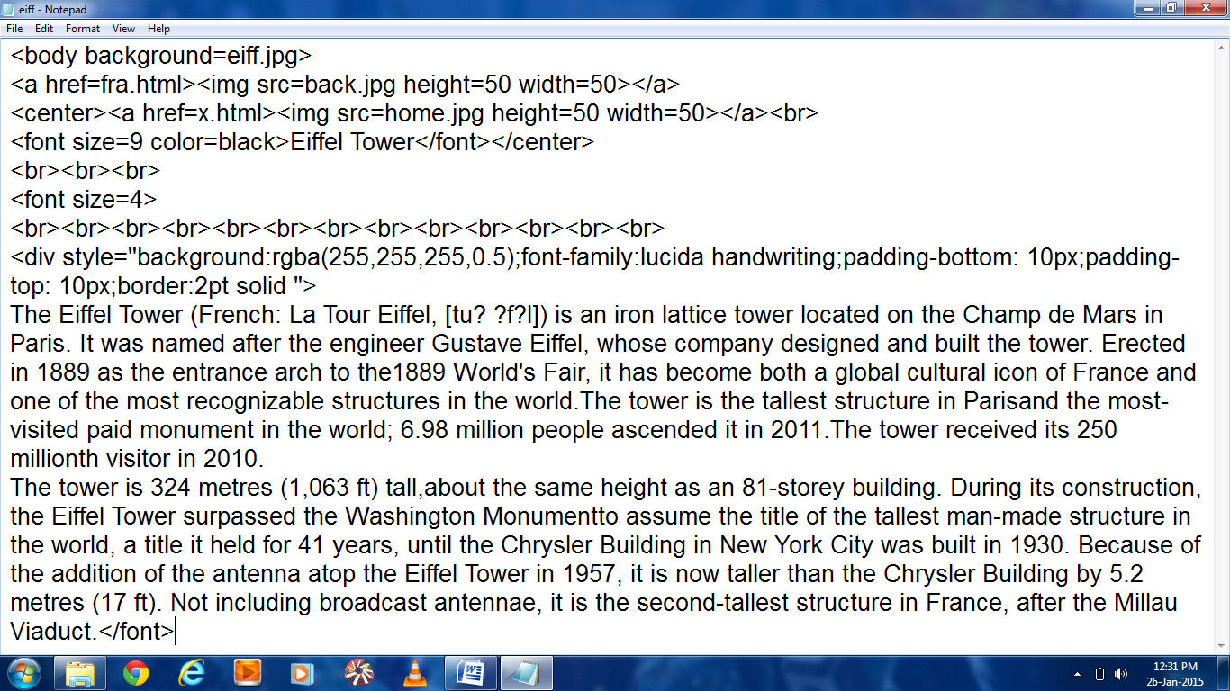

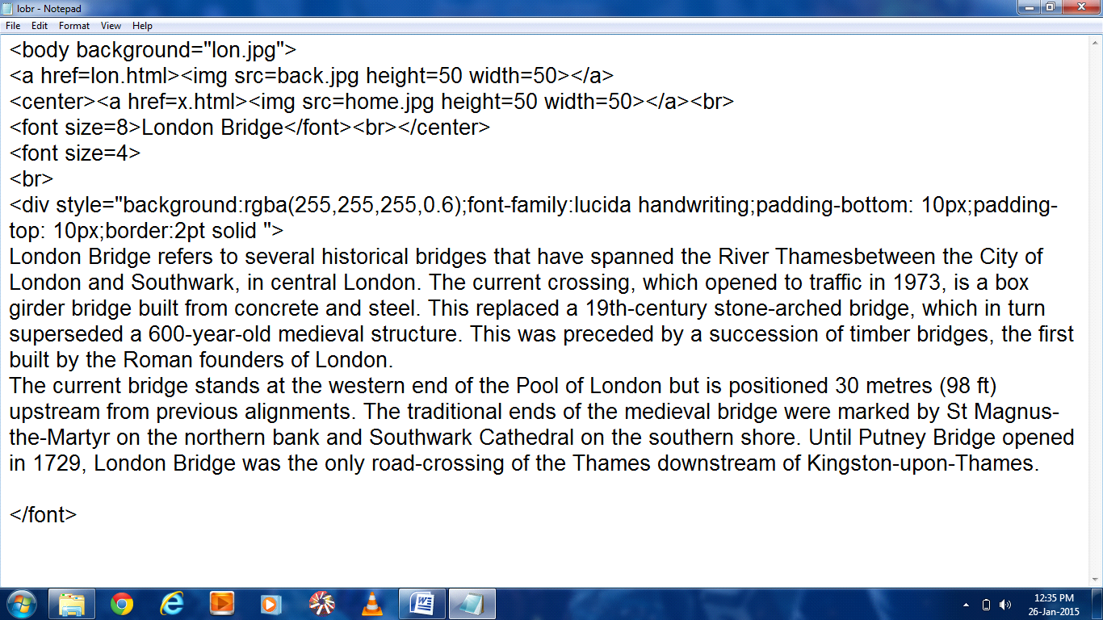

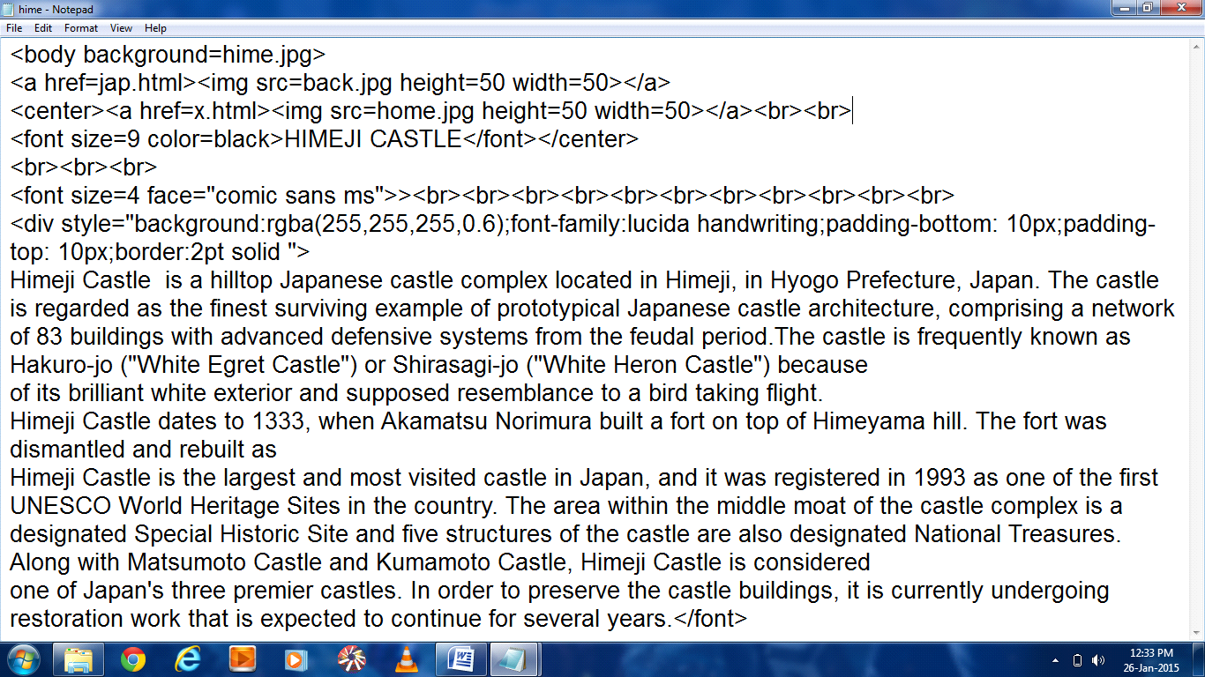

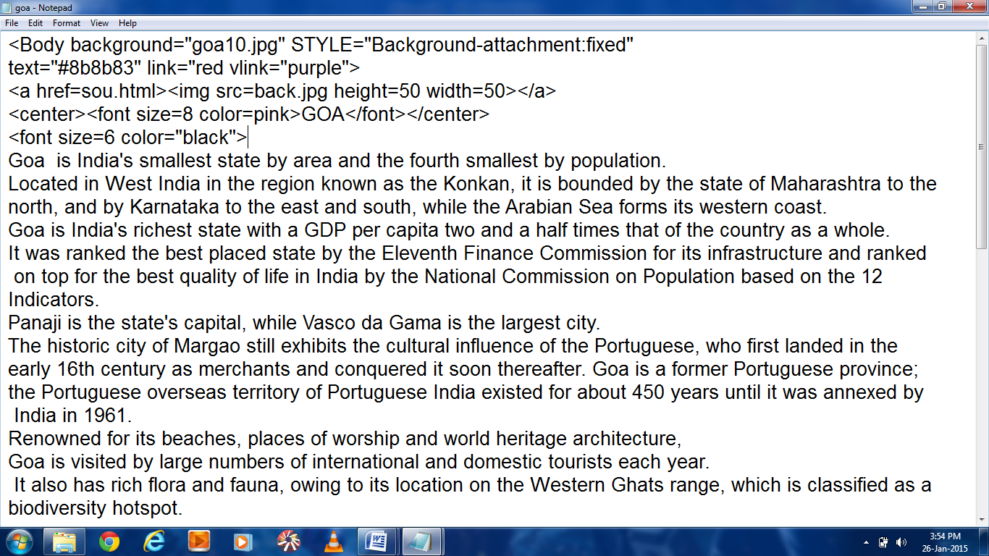

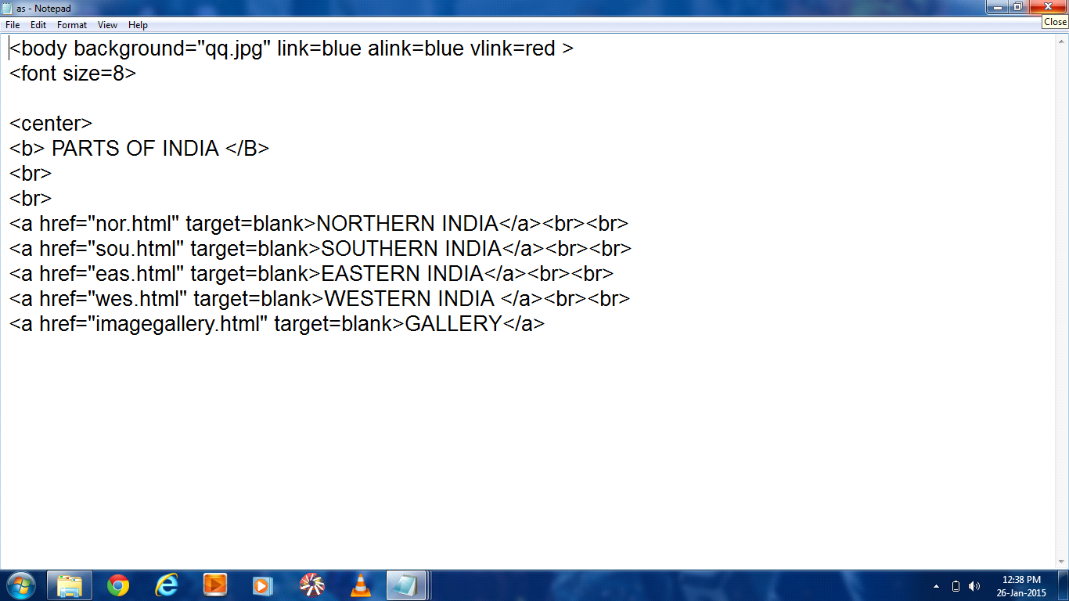

*BIBLIOGRAPHY*

This project has been made from:

* Multimedia and web technology (class XII)
* [www.google.com](http://www.google.com/)
* [www.yatra.com](http://www.yatra.com/)
* [www.makemytrip.com](http://www.makemytrip.com/)